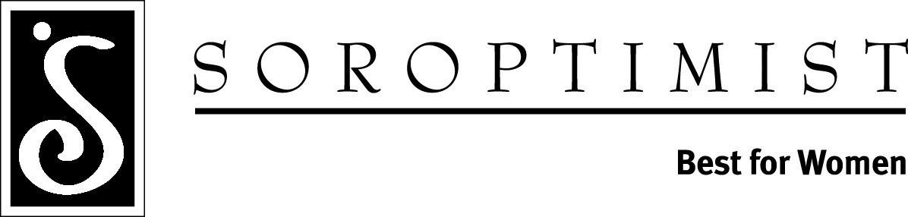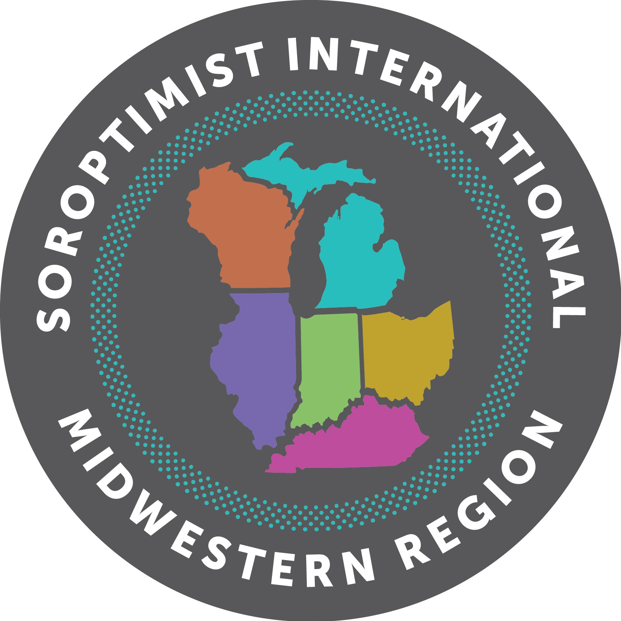

Virginia M. Wagner Educational Award
Fact Sheet

- Each Soroptimist International of the Americans Region use to select and support a specific region project. In 1972, the Midwestern Region established as their Region Project an award given annually to a woman who is attending college/university to further her education in order to provide advancement.

At the 2004 Spring Conference, the name was changed from the “Region Award Project” to the “Virginia M. Wagner Educational Award,” in honor of Dr. Virginia M. Wagner, MWR Governor 1982-1984, to commemorate her interest in higher education for women.

- Only those women residing in the states of Illinois, Indiana, Kentucky, Michigan, Ohio, and Wisconsin may apply.

- Women may apply for only one Soroptimist award, and to only one club, per calendar year.

- Judging at the club, district, and region level is conducted by three non-Soroptimists who utilize a standardized scoring sheet for each application.

- Judging is based on effort toward education (35%), general impression (20%), scholarship (15%), extra-curricular activities (15%), and need (15%). Therefore, this award is particularly relevant for the woman in a bachelors, masters, or doctoral program of study.

- The winner of the “Virginia M. Wagner Educational Award” will be awarded $2,500.00 and each of the remaining 3 district winners will receive $1,000.00 each at Spring Conference.

- There are three primary differences between the Federation’s Live Your Dream Award (LYD) and the Region’s Virginia M. Wagner Educational Award:

  - The LYD Award is weighted toward need.
  - The LYD Award can be given to a woman who is enrolled in a non-college or technical training program.
  - The Virginia M. Wagner Educational Award is for Midwestern Region only. Federation (SIA) does not provide any funding for the award.
Soroptimist International Midwestern Region 2019-2020

