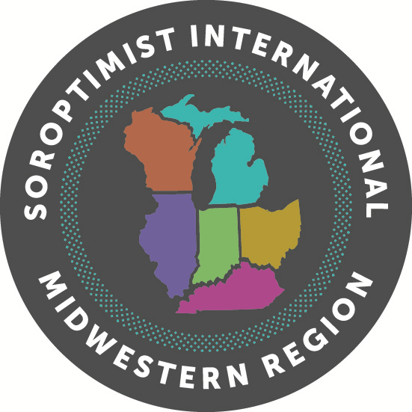**Soroptimist International Midwestern Region**

**Virginia M. Wagner Educational Award**



**Are you a woman living in Illinois, Indiana, Kentucky, Michigan, Ohio or Wisconsin and seeking a baccalaureate or higher degree?**

**The Virginia M. Wagner Educational Award was designed to help women achieve their higher education goals.**

**Candidates are judged on the following criteria:**

* **Effort toward education**
* **Scholarship**
* **Extra-curricular activities**
* **Financial need**
* **General impression**

**For information about applying for the Virginia M. Wagner**

**Educational Award, please contact:**

**Soroptimist International of**

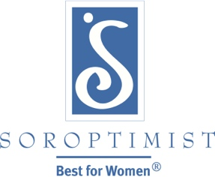

**Name**

**Email**

**Phone**

**Club Application Deadline: January 15, 2021**

**Amount of Club Award**