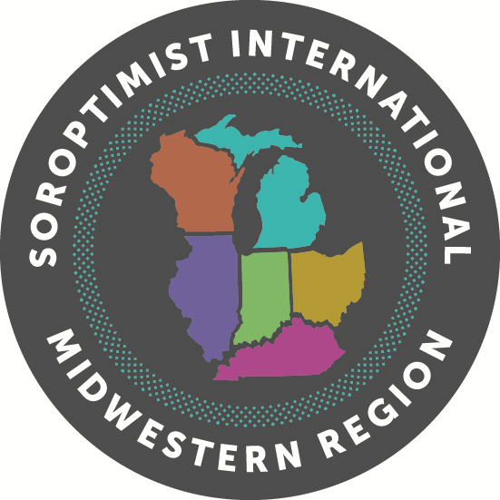**Midwestern Region**

**Virginia M. Wagner Educational Award**



**2020 Club Transmittal Form**

**This form must be sent along with your Club’s winning application and received by February 15, 2020, to District Director.**

Club Data:

Club: Club Chairperson: Club Chairperson Contact Information: Phone Email

Winner Data:

Name of Club Winner: Club Winner Social Security Number:

Statistical Data:

How many applications did your club send out? How many were returned?

How many were incomplete? How many were judged?

How many were At-Large applications?

Club Award Data:

Number of cash awards

Amount(s) of award(s)

Number of non-cash awards: Nature of Award(s)

Judges Names:

1.

2.

3.

Signature of Club Chairperson:

----------------------------------------------------------------------------------------------------------------------------------------------------------------------------------------------

**District I Director**

**Susan Frankel – SI Fond du Lac**

291 Old Pioneer Road

Fond du Lac, WI 54935

C: 920-251-2559

[smfrankel5@gmail.com](mailto:lgbradburn@gmail.com)

**District II Director**

**Barb Flory – SI Middletown**

5016 Oakview Drive

Middletown, OH 45042

H: 513-422-1882

[bflory@cinci.rr.com](mailto:bflory@cinci.rr.com)

**District III Director**

**Mary Pilon – SI Wyandotte/Southgate/Taylor**

1711 Chestnut

Wyandotte, MI 48192

C: 313-405-5807

[pilonmary0@gmail.com](mailto:cindiames@gmail.com)

**District IV Director**

**Christine Shearer- SI Canton/Stark County**

4590 Rockridge Way

Copley, OH 43421

C: 216-408-4124

[FowlerArtistic@gmail.com](mailto:JodyClark62@yahoo.com)