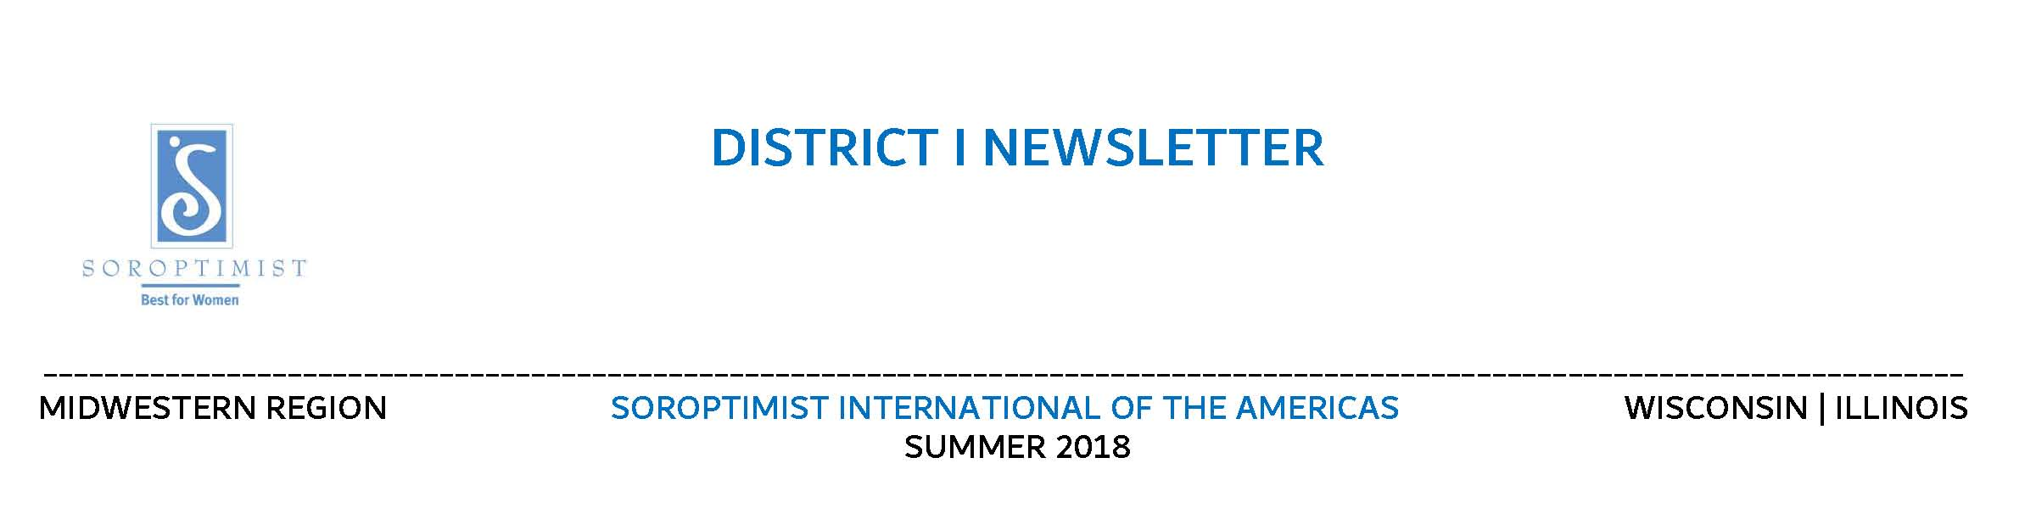
July 2020
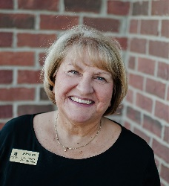
FROM THE DIRECTORS CHAIR
The July Region Board meeting included the installation of the new Board. It was held in Middlebury IN and all CDC requirements were followed. Masks were worn and seating was spaced out.
A big thank you to former Governor Vivian Walczesky who came and installed the 2020/2022 region board. We all loved our Olymipic Gold medals and flowers. The new pins are beautiful. 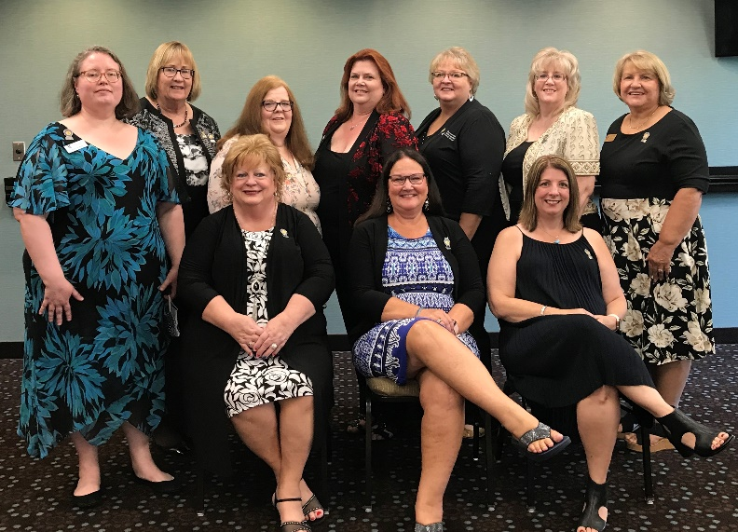
Left to right: Back row: Laura Ferguson, District II Secretary, Ruth Waggoner, District II Director,
Patricia Cavell, District III Secretary, Kellie Klingel, District III Director, Connie Gindt, District I Secretary, Abby Boudon, District IV Director, Susan Frankel, District I Director,
Front Row: Audrey Jarvey, Treasurer, Darcy Merritt, Governor and Christine Shearer, Governor-Elect. Missing are: Sheila Zingler-Gilbert, Secretary and Mary Lorenzo, District IV Secretary.
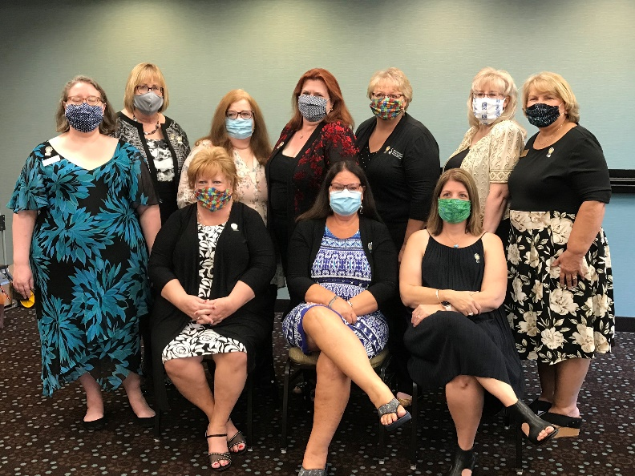
Here we are with our masks!
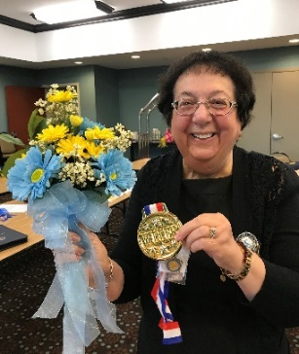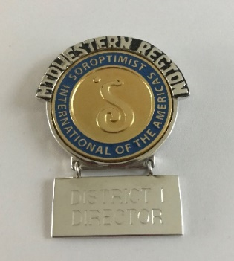
Vivian with the bouquet and medal that she presented to each member, and the new region pin.
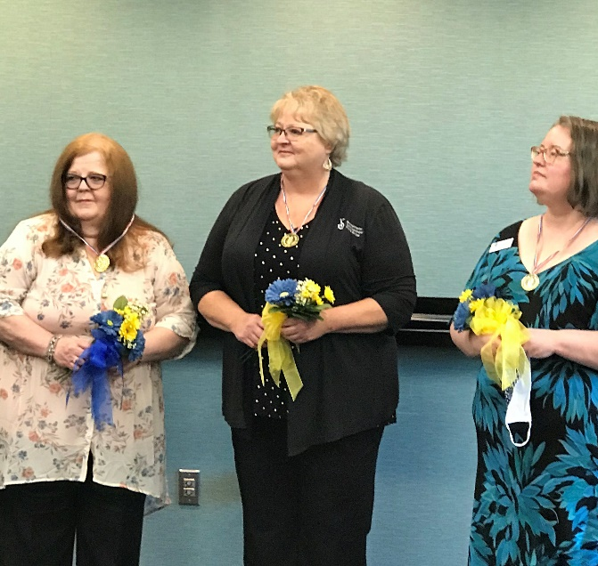
The District Secretaries being installed (Mary was there in spirit!)
Vivian also presented the Celebrating Success Certificates to District Directors - District I Certificate are listed below:
2019-2020 Soroptimists Celebrating Success
FUNDRAISING AWARD
SI/BLOOMINGTON NORMAL IL
Participation - Bloomington Normal Club 250
SI/FOND DU LAC WISCONSIN
2nd PLACE In Honor of Excellence – Soroptimist Bazaar
SI/ILLIANA
Participation Certificate - PADS
MEMBERSHIP AWARD
SI/BLOOMINGTON NORMAL IL
3RD PLACE In Honor of Excellence - International Women’s Day Breakfast
SI/ILLIANA
Participation Certificate – PADS
Participation Certificate – Women of Distinction Awards Luncheon
PROGRAM AWARD
SI/BLOOMINGTON NORMAL IL
3RD PLACE - In Honor of Excellence –
Partnering with Boys & Girls Clubs Smart Girls Program and Career Awarenesss
SI/CHICAGO IL
3RD PLACE - In Honor of Excellence –
Dream It Be It Rising above Obstacles in the Workplace
Participation Certificate – Soroptimist Impact through Days for Girls Partnership
SI/FOND DU LAC WISCONSIN
Participation Certificate – Supporting Camp Reunite
SI/ILLIANA
Participation Certificate – Women of Distinction Awards Luncheon
Participation Certificate – Free the Girls
Participation Certificate – PADS
Participation Certificate – Sojourner Truth House Shoe Drive
Participation Certificate – Dream It Be It Workshop
Participation Certificate – Dream It Be It Conference
Participation Certificate – Coming to the Need of the South Suburban Family Shelter
SI/MILWAUKEE WISCONSIN
Participation Certificate – Cathedral Center Movie in Baskets
PUBLIC AWARENESS
SI/BLOOMINGTON NORMAL IL
2ND PLACE In Honor of Excellence – Girls World Expo
SI/ILLIANA
Participation Certificate – AKA EXPO
GREAT JOB DISTRICT I !!
Without Spring Conference, the Annual Club awards were presented by Governor Darcy to District Directors - District I Club Awards are listed below. I will send the certificates to all Presidents as soon as possible.
SI/BLOOMINGTON NORMAL IL
Dreamers Level for your Contribution to 2018-2019 CLUB GIVING
Participating in the LIVE YOUR DREAM: EDUCATION AND TRAINNG AWARDS FOR WOMEN
Participating in DREAM IT, BE IT: CAREER SUPPORT FOR GIRLS
Certificate of Appreciation in Honor of your efforts to increase SIA’S COLLECTIVE IMPACT
SI/CHICAGO, IL
Participating in the LIVE YOUR DREAM: EDUCATION AND TRAINNG AWARDS FOR WOMEN
Participating in DREAM IT, BE IT: CAREER SUPPORT FOR GIRLS
Certificate of Appreciation in Honor of your efforts to increase SIA’S COLLECTIVE IMPACT
SI/FOND DU LAC WISCONSIN
Dreamers Level for your Contribution to 2018-2019 CLUB GIVING
Participating in the LIVE YOUR DREAM: EDUCATION AND TRAINNG AWARDS FOR WOMEN
Participating in DREAM IT, BE IT: CAREER SUPPORT FOR GIRLS
Certificate of Appreciation in Honor of your efforts to increase SIA’S COLLECTIVE IMPACT
SI/ILLIANA IL
Contributors Level for your Contribution to 2018-2019 CLUB GIVING
Participating in the LIVE YOUR DREAM: EDUCATION AND TRAINNG AWARDS FOR WOMEN
Participating in DREAM IT, BE IT: CAREER SUPPORT FOR GIRLS
Certificate of Appreciation in Honor of your efforts to increase SIA’S COLLECTIVE IMPACT
SI/MILWAUKEE, WI
Participating in the LIVE YOUR DREAM: EDUCATION AND TRAINNG AWARDS FOR WOMEN
Certificate of Appreciation in Honor of your efforts to increase SIA’S COLLECTIVE IMPACT
SI/SUBURBAN CHICAGO, IL
Contributor Level for your Contribution to 2018-2019 CLUB GIVING
Participating in the LIVE YOUR DREAM: EDUCATION AND TRAINNG AWARDS FOR WOMEN
Participating in DREAM IT, BE IT: CAREER SUPPORT FOR GIRLS
Certificate of Appreciation in Honor of your efforts to increase SIA’S COLLECTIVE IMPACT
Please congratulate you members and thank them for all their hard work these past years and lets all pray for a safe and healthy coming year.

TO DO
Have you sent your updated roster, list of officers and chairs, budget, and by-laws to me at smfrankel5@gmail.com and Connie Gindt at connie@ep-direct.com yet? If not please send as soon as possible or let me know that you will be bringing them to District Meeting.
ACORN GUILD
I know you have seen Hildy the Acorn Guild squirrel. You can join the Acorn Guild by making a $100 donation. Your donation helps the Acorn Guild as it supports and finances the Dr. Virginia M. Wagner Award. This is our exclusive Midwestern Region award for which we, as members, are responsible for funding. This year without Spring Conference we did not get your donations. Please consider sending a check to the Region to keep this award funded.
The acorn squirrel changes annually so please consider contributing every year. This year is a squirrel charm that you can add to your charm bracelet with the Midwestern Region charm also sold by the region. Remember the Virginia Wagner Award helps support a young lady as she pursues her higher education.

NEWSLETTERS
Your club newsletter is a great way for members to keep in touch. Even if you do not have a club project or upcoming events you could ask your members to let you know what they are doing during this unusual time. Include the members of the region board and Chris Speedie, our webmaster, and Ross Braun our VISION editor on your newsletter emails. Their emails are listed in the next article.

MIDWESTERN REGION WEBSITE
The Region is updating its Website. We are also requesting updated pictures. Please also send these to me at Smfrankel5@gmail.com . We are hoping to have this up and running as soon as possible.
If you are posting information about your club send that information to Chris Speedie at crspeedie@sbcglobal.net to have your information posted on Midwest Webpage. For posting in the Region Newsletter the Vision send this information to Ross grossepointsoroptimist@gmail.com .

LIVE YOUR DREAM | DR. VIRGINIA M. WAGNER AWARDS
District I The Live Your Dream Award
The SIA Portal opens on August 1st. Please make sure your LYD Chairs are aware and familiar with the process.
Dr Virginia M Wagner Award - Thank you all for being a part of this award. Have you found your club Chair? Without knowing how schools will be working this year, we need to think of other ways to get the word out on our awards. Newspapers, radios, notices on Facebook, Instagram and any other process are options to consider. If you have some ideas please let us all know.
MEMBERSHIP
In District I we have 6 clubs. I am sorry to say that this year we have lost about 11 members. Not sure why, if it is a financial issue please reach out to me -the region might be able to help. I’m attaching the Exit Form for non-returning members to fill out. Upon completion of the form, share it with me and we will work together to make adjustments to our clubs and retain members going forward. The form will give us valuable information.

DREAM IT, BE IT
I hope you are continuing to work on this program. I know many DIBI events have been postponed till later this year or next year please let me know as I would like to help if possible. Thank you.

DISTRICT I & III MEETING
Mark your calendar for the next District I and III Meeting on October 16th and 17, 2020 at the Essenhaus Inn and Conference Center, Middlebury, Indiana. The plan right now is to have an in-person meeting. I will let you know as time gets closer if anything changes.
We sent out a survey asking each member to let us know what you feel we should cover at District Meeting, even if you cannot attend. The response so far are meager with the exception of one club (they had 100% returned). I ask that you fill out the survey and send back to me by the end of July so we can cover your club’s needs.

SIA CONVENTION
The 2020 SIA Convention was sadly cancelled. But SIA is planning on a virtual meeting, see link below and if you missed it, I believe you can watch later. I know they started July 23rd today.
https://www.soroptimist.org/for-clubs-and-members/whats-new/2020/virtual-convention.html
The celebration of our 100th Anniversary is set for October 2021 in San Francisco. Watch for more information as it becomes available.

ROUNDTABLE MEETING
We are planning another District I roundtable meeting. Waiting for the right time. We are considering a Virtual meeting. Will let you know when and hope this will work for you.

IN CLOSING
Connie and I want to thank you all for everything you do to help your club as well as keeping in touch with members. We know it is hard right now without any events in the works. Staying in touch with each other is key.
If there is anything, we can do to help you in the months ahead please let us know. Remember to invite us to your virtual meetings as we would like to join you. We could not do this without you!

Yours in service,
Susan Frankel Connie Gindt District I Director District I Secretary 920-251-2259 920-923-6310 smfrankel5@gmail.com connie@ep-direct.com

