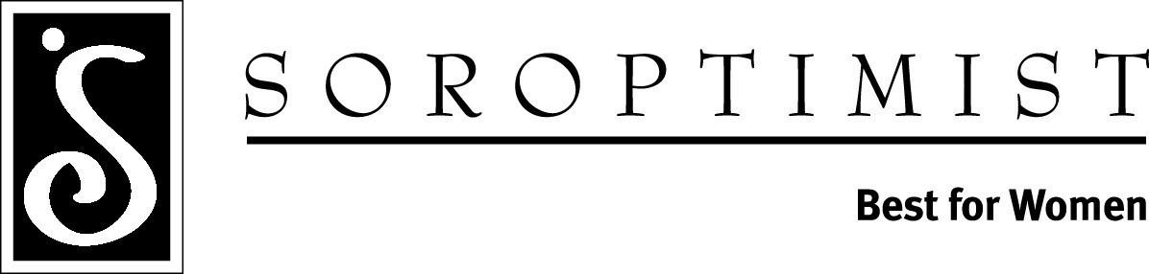
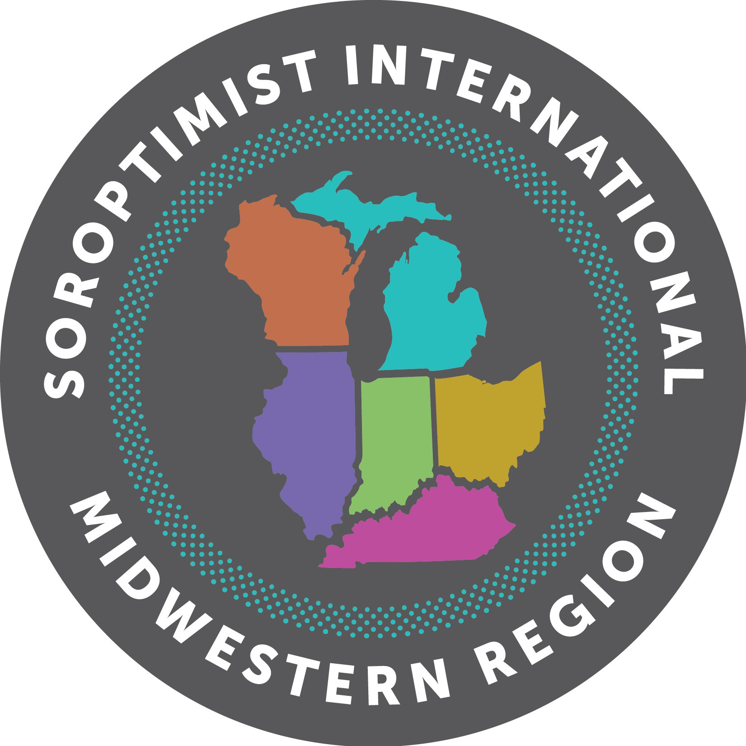

Dr. Virginia M. Wagner

November X, 2018

Dear Counselor or Advisor,

I am pleased to announce the Virginia M. Wagner Educational Award opportunity for women, presented by Soroptimist International of Canton/Stark County. Soroptimist is an international volunteer organization for business and professional women who work to improve the lives of women and girls, in local communities and throughout the world. I hope you will encourage participation from women at your college or university to apply for this award. The Virginia M. Wagner Educational Award is unique to the Soroptimist Midwestern Region, and therefore only women attending schools in the states of Illinois, Indiana, Kentucky, Michigan, Ohio and Wisconsin are eligible to apply.

Some facts about the Virginia M. Wagner Educational Award include:

- It is a financial award for women seeking a bachelors, masters or doctorate degree.
- Applicants taking on-line courses or seeking degrees from on-line universities ARE eligible.
- Information about the award is available on our club’s website at www.bestforwomencanton.org.
- At the Canton/Stark County club level, between $350 - $500 is awarded to winners annually.
- Winning applicants go on to compete at the District level ($500), and those winners at the Region level ($2500).

Applicants need only visit our club’s website—www.bestforwomencanton.org—and download the application to get started!
Applications are due by January 15, 2019. Please don’t hesitate to contact me with any questions!

Sincerely,

Chair Name
Club Chairperson, Virginia M. Wagner Educational Award
Home Club
Email

