Soroptimist International of Chicago Summary
2019-2020
It has been a short club year but we had helped our community in numerous ways.
Oct.- Eliminating Sexual Violence -Speaker from Resilience
12 Bags of gently used bras were donated to the Free the Girls micro-enterprise programs
Nov.- Hosted Days for Girls workshop- Members provided dinner and assisted in making the items for the kits. Our members donated underwear, washcloths, soap, and fabric.
During the Spring quarantine member JoAnne Klein assembled 100 complete kits. 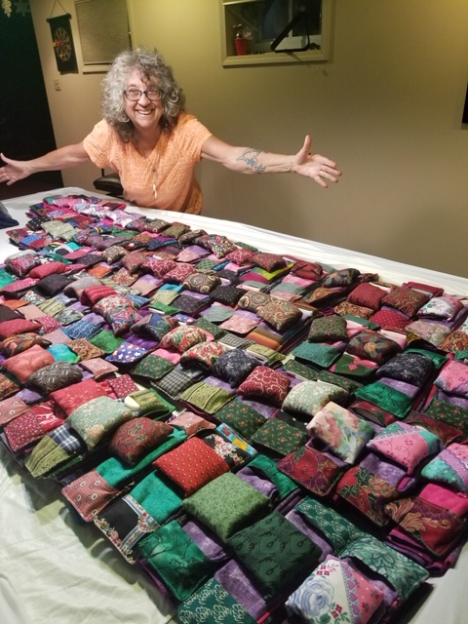
Days for Girls are no longer using plastic bags instead they made waterproof fabric bags.
Dec.- Member attended Movie #Female Pleasure sponsored by Soroptimist of Switzerland, the story of 5 women exploring obstacles that stand in the way of female sexuality in the 21st century. Celebrated at our annual Holiday party and Fundraiser.
March - Presentation of Money Smart program for teens at Taft Public High School,
in partnership with Wintrust Bank. Unfortunately, we were unable to present our Dream It, Be It program: Overcoming Obstacles in the Workplace, when the schools closed.

In Mid-March the world changed with the onset of the corona Virus and quarantine.

Realizing that the needs of so many were greater than before SI Chicago doubled our annual donation to Family Rescue, Domestic Violence shelter and outreach programs.

We also contacted New Moms, an organization that provides shelter, support and job training for new mothers. 80% of the mothers and children were homeless.
We donated toiletries, clothing, toys, towels, copy paper, pens and a laptop for a mother taking on-line education courses.
SI Chicago was unable to host the annual Education Award dinner. $1,000 awards were sent to both winners.

Live Your Dream recipient Madethe Mdegella, is the mother of three girls. (Photo)
Madethe works as an aide in a nursing home and became an essential worker on the front line.

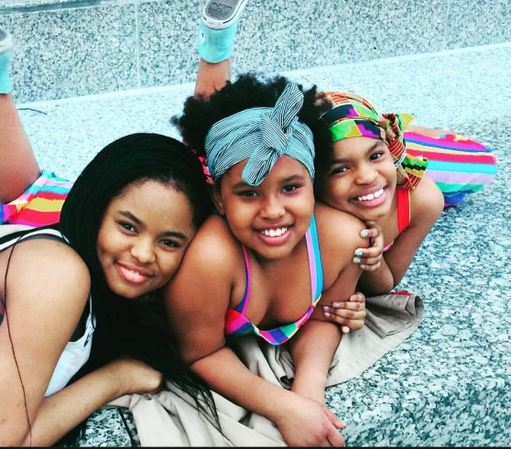

The Virginia Wagner award recipient, Stephanie Verderame, is finishing her nursing degree at UIC. (see her note below.)
“Thank you again for this award; I will be using the funds to help pay for my summer course (my last clinical rotation!) Since federal loans don’t cover summer sessions, we always have to pay for them out of pocket and this award will offset that tremendously.”

Each of our programs and projects furthered the Soroptimist vision and mission.
SI Chicago members have made a significant impact in the lives of Women and Girls
Locally and Internationally.
SOROPTIMIST INTERNATIONAL OF THE AMERICAS
OUR VISION: Women and girls have the resources and opportunities to reach their
full potential and live their dreams.
OUR MISSION: Soroptimist is a global volunteer organization that provides women and girls
with access to the education and training they need to achieve economic empowerment.

