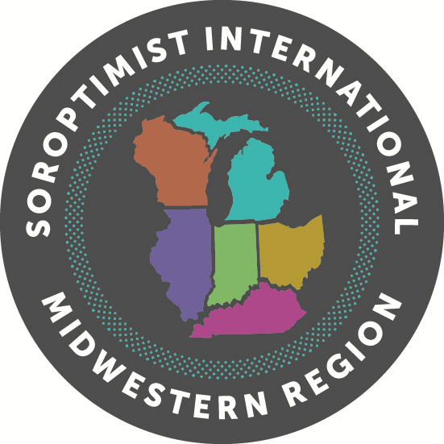**Midwestern Region**

**Virginia M. Wagner Educational Award**

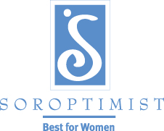**2021 Club Transmittal Form**

**This form must be sent along with your Club’s winning application**

**and received by February 15, 2021 to your District Director.**

Club Data:

Club: Club Chairperson: Club Chairperson Contact Information: Phone Email

Winner Data:

Name of Club Winner: Club Winner Social Security Number:

Statistical Data:

How many applications did your club send out? How many were returned?

How many were incomplete? How many were judged?

How many were At-Large applications?

Club Award Data:

Number of cash awards

Amount(s) of award(s)

Number of non-cash awards: Nature of Award(s)

Judges Names:

1.

2.

3.

Signature of Club Chairperson:

---------------------------------------------------------------------------------------------------------------------------------------------------------------------------------------------

**District I Director**

**Susan Frankel – SI Fond du Lac**

291 Old Pioneer Road

Fond du Lac, WI 54935

C: 920-251-2559

[smfrankel5@gmail.com](mailto:smfrankel5@gmail.com)

**District II Director**

**Ruth Waggoner - SI Kenton/Hardin County**

13658 Township Road 40

Dunkirk, OH 45836

H: 419-957-5417

[ruthwaggoner55@gmail.com](mailto:ruthwaggoner55@gmail.com)

**District III Director**

**Kellie Klingel – SI Flat Rock Area**

20115 Roche

Brownstown Twp., MI 48183

C: 734-664-6709

[ktklingel@yahoo.com](mailto:ktklingel@yahoo.com)

**District IV Director**

**Abby Bouton /SI Columbus Franklin County**

2101 Mackenzie Drive

Columbus, OH 43220

C: 614-285-8212

[abbouton@yahoo.com](mailto:abbouton@yahoo.com)